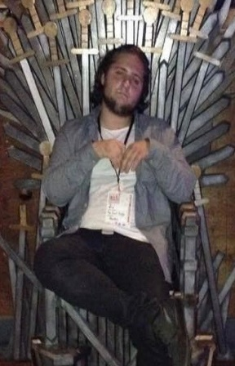
A family’s message about Nicholas Shannon
On behalf of Joe, Theresa and the entire Shannon family, we would like to thank every individual playing in the Nicholas Shannon Memorial Jamboree in his memory. This gesture by the Over-30 league in recognizing his memory, paying tribute to our son Nick and giving back to our family means a lot.
Nick was 27 and passed away unexpectedly August 2018. For those of you who never knew Nick, please see some thoughts that we wanted to share with you so that you know a little bit more about our son.
On top of being a great person, our son was a great hockey player. Nick was a smart guy and very talented. His love in life was centered on music which inspired him to become very versatile in learning how to play the piano, guitar, bass guitar and drums. The unique thing about how Nick learned all these instruments is that he was self-taught and never took a lesson. Nick soon took his musical talents and joined a band called the Sunset Kings.
Nick was attending college, getting all A’s in his classes, studying to become an accountant. With his focus on playing music with his band, and going to school, Nick made time to play ice hockey at night. His favorite number was #5. Nick was a hockey guy who was a smart player with hands like his dad that had a knack of finding the net for goals.
This short summary doesn’t do Nick justice as he was a person that was easy going with all those around him. As his father, it has helped me talk about our son around some of you, probably too much, and I will continue to keep his memory alive.
We love our son Nick very much and miss him so much every day. Your gesture of honoring his memory means a lot to us and helps in the ongoing healing process.
Sincerely,
Joe and Theresa and the entire Shannon family

